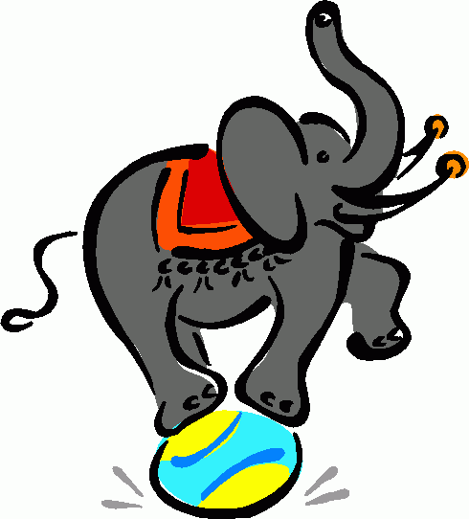
Comparison of adjectives
nice nicer
long longer
high higher
small smaller
big bigger
hot hotter
thin thinner
happy happier
easy easier
busy busier
Long adjectives
beautiful more beautiful
expensive more expensive
useful more useful


Add -ER

The elephant is bigger
The monkey is big
double consonant



-y -ier
This clown is funny
These monkeys are funnier

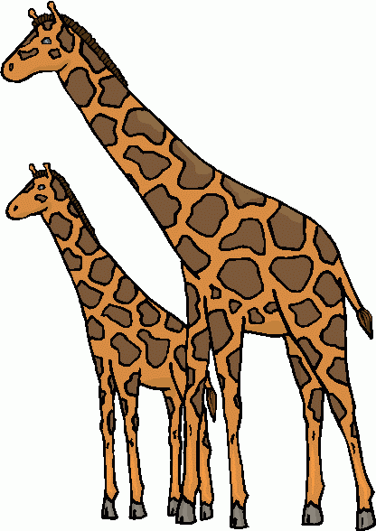
This giraffe is taller

The giraffe is tall
IRREGULAR COMPARATIVES
good better
bad worse
much more
little less
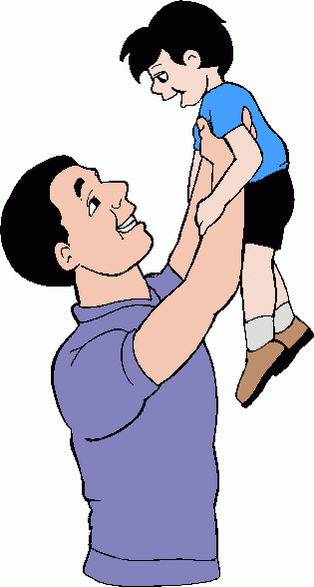
The son is young
The father is old

We can compare people, things, animals, etc...
comparative adjective + than
John is stronger than Henry
A lion is more dangerous than a dog
More + adjective + than

The son is younger than the father
The father is older than the son


exercises
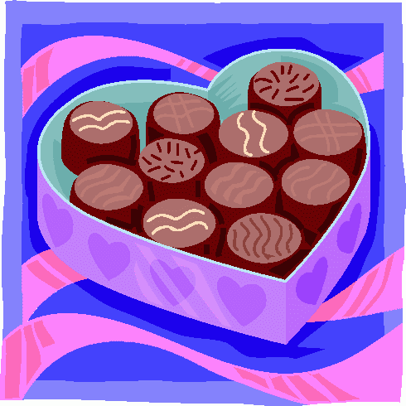
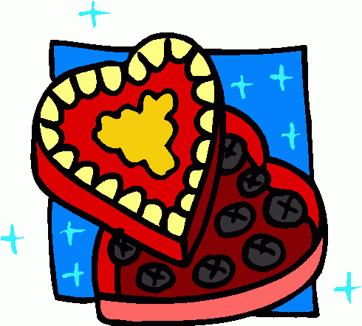
WRITE COMPARATIVE ADJECTIVES
A
B
12 €
15 €
rich
fast
heavy
slow
Warm
cold
Strong

Which box of chocolates is cheaper? ______


Make comparisons
David
Age: 35
Weight: 76 Kgs
Height: 1.72
Money: 2,500€
House: 2 rooms

Linda
Age: 39
Weight: 83 Kgs
Height: 1.63
Money: 3,600€
House: 4 rooms

Complete with the comparative adjective
1.- Linda is ............ (old) than David.
2.- David is ............(slim) than Linda.
3.- Linda is ............ (tall) than David.
4.- Linda is ………. (rich) than David.
5.- David’s house is ……... (small) than Linda’s house.

COMPLETE THE SENTENCES WITH A COMPARATIVE ADJECTIVE

1.- Saturn is ……………. (small) than Jupiter.
2.- Today is ……………… (cold) than yesterday.
3.- Martha is …………………….. (intelligent) than Paul.
4.- Frankenstein is ………………..…. (ugly) than an alien.
5.- Mars is …………… (dry) than the Earth.
6.- My father’s car ………………….. (expensive) than my friend’s car.
7.- August is …………………… (hot) than December.
8.- Your schoolbag is ………………. (new) than mine.
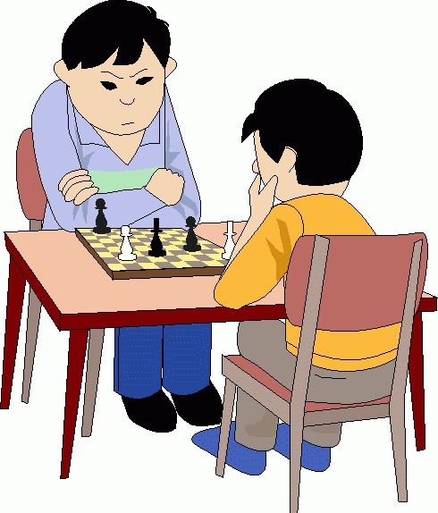
9.- Bob, my cat is ……………………. (happy) than your dog.
10.- The lions are …………………….. (dangerous) than the penguins.
11.- The high school is ……………………. (near) than the bookshop.
12.- Julio is ……………………. (good) than his sister.
11.- Football is ……………………. (easy) than chess.
13.- Tom and Peter are …………………… (friendly) than Tommy.
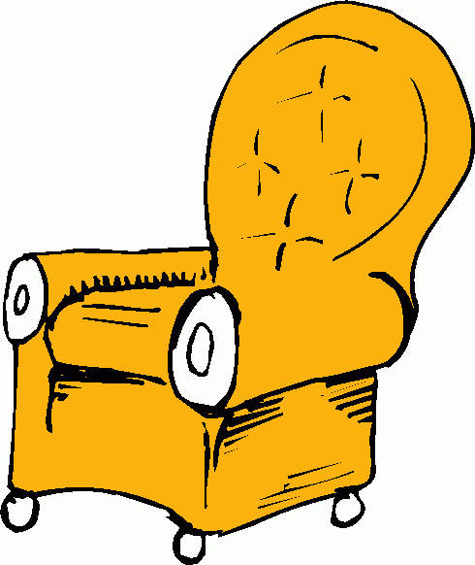
16.- Planes are …………………………. (fast) than trains.
17.- Snails are ………………….. (slow) than dogs.
18.- Alice is ………………………. (beautiful) than her cousin.
19.- An armchair is …………………………. (comfortable) than a chair.
20.- That garden is ……………………………… (nice) than Julie’s garden.
21.- Swimming is …………………………. (good) than running.
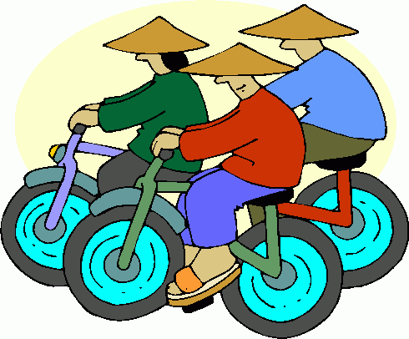
22.- Feathers are ………………………… (light) than iron.
23.- Chinese is …………………………. (difficult) than English.
24.- This man sings ……………… (bad) than my father.


